CREDIT CARD PAYMENT SYSTEM
A Full-Stack Secure Payment Management Application

Submitted by: Niranjana V
Date of Submission: 03/10/2026
Technology Stack: MERN Stack (React + Node + Express)

GitHub Link : https://github.com/Manira2909/credit-card-payment-system

Abstract :

- The Credit Card Payment System is a full-stack web application designed to simulate secure credit card management and transaction processing.
- It provides users with a dashboard to view saved cards, add new cards, check available balance, and track transaction history.
- The system features a decoupled architecture with a React frontend and a RESTful Express backend, ensuring scalability, security, and real-time data handling.

Problem Statement :

- Traditional payment systems lack user-friendly dashboards for card management.
- No centralized view for multiple cards and transaction history.
- Need for a secure, fast, and responsive system to simulate real-world payment gateway logic.

Objectives :

- To develop a secure platform for managing multiple credit cards.
- To implement CRUD operations for cards (Add, View).
- To enable secure payment simulation and transaction logging.
- To build a scalable REST API architecture.
- To provide a responsive and intuitive UI/UX.

System Architecture :

- Client Tier (Frontend): React + Vite | Runs on Port 5173
- Server Tier (Backend): http://Node.js + http://Express.js | Runs on Port 5000
- Communication: REST API + CORS + JSON
- Data Layer: In-Memory Storage (Scalable to MongoDB)

- Flow:

User Action -> React Component -> Axios API Call -> Express Route -> Data Processing -> JSON Response -> UI Update

Technology Stack :

Frontend:
  - http://React.js (Component-Based UI)
  - Vite (Fast Build Tool)
  - Axios (API Integration)
  - Tailwind CSS / CSS3 (Responsive Design)

Backend:
- http://Node.js (Runtime)
- http://Express.js (Web Framework)
- CORS (Cross-Origin Security)
- Nodemon (Development)

Key Modules :

1. Card Management Module:
- View all saved cards with masked numbers (*_ *_ **** 1111)
- Add new cards with validation (Cardholder, Expiry, CVV)

2. Dashboard Module:
- Total balance overview
- Card type detection (Visa, Mastercard)

3. Transaction Module:
- Real-time transaction history
- Payment simulation with merchant and amount
- Date-wise tracking

API Endpoints (RESTful API Design):

Method | Endpoint | Description
GET | `/` | Health Check - Backend Status
GET | `/api/cards/` | Fetch All Cards
POST | `/api/cards/` | Add New Card
GET | `/api/transactions/` | Fetch Transaction History
POST | `/api/pay/` | Process a Payment

Security Features Implemented :

- Card Number Masking: Displaying only last 4 digits
- CORS Enabled: Preventing unauthorized cross-origin requests
- Backend Validation: Mandatory field checks for card number, holder, expiry
- No Sensitive Data Exposure: CVV not returned in GET requests (in production)
- Input Sanitization via http://express.json()

Challenges Faced & Solutions :

Challenge 1: `Cannot find module index.js` Error
Solution: Corrected http://package.json main entry to `server.js` and updated scripts.

Challenge 2: `Card added locally (backend not connected)` Message
Solution: Implemented flexible API routing `['/api/cards', '/api/cards/']` and enabled CORS.

Challenge 3: Port Conflict between Frontend and Backend
Solution: Decoupled ports - 5173 for Vite and 5000 for Express.

Future Enhancement :

- Integration with MongoDB for persistent storage
- JWT Authentication & User Login
- Payment Gateway Integration (Stripe / Razorpay)
- OTP Verification for Transactions
- AES Encryption for Card Data
- Admin Dashboard for Analytics
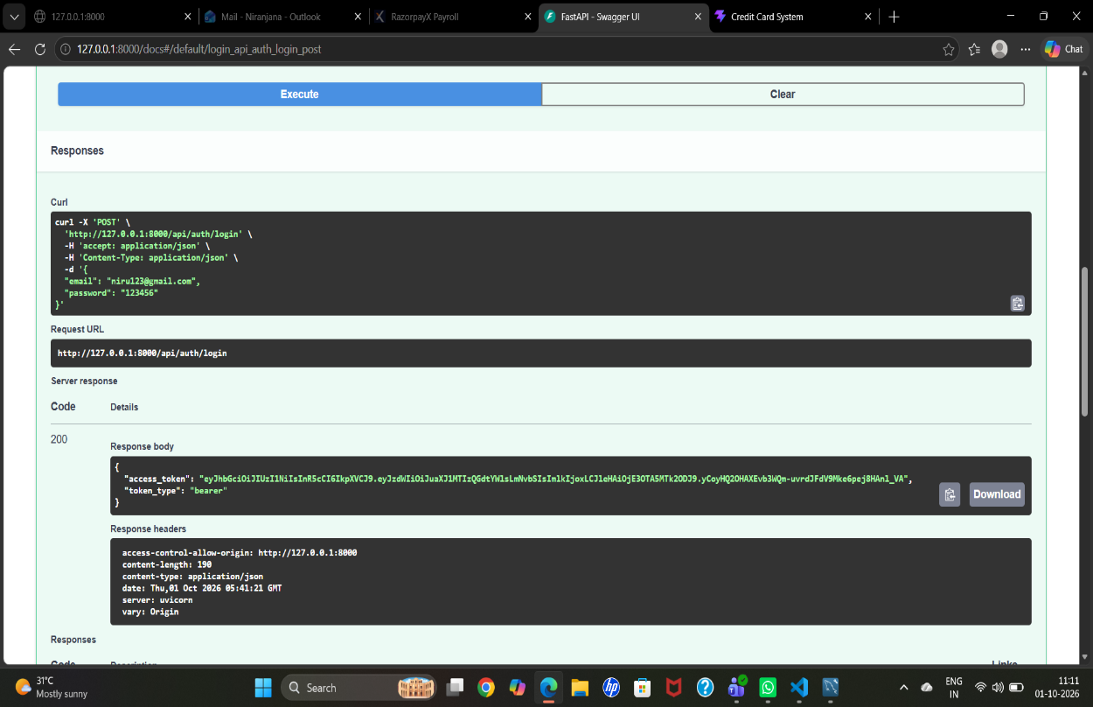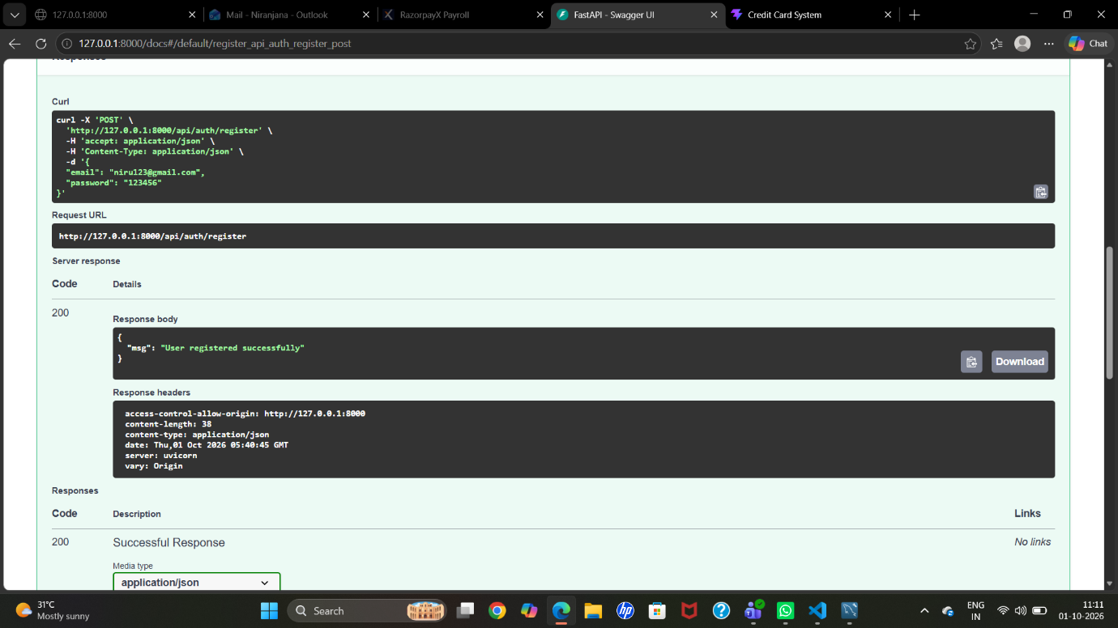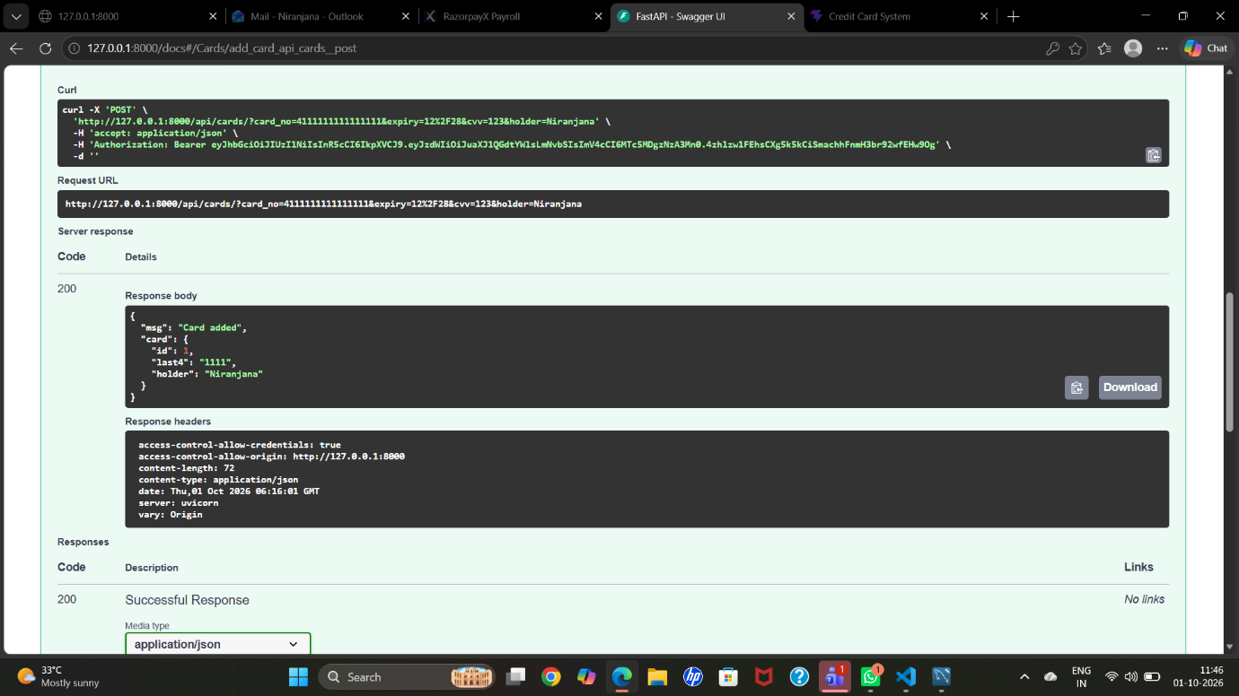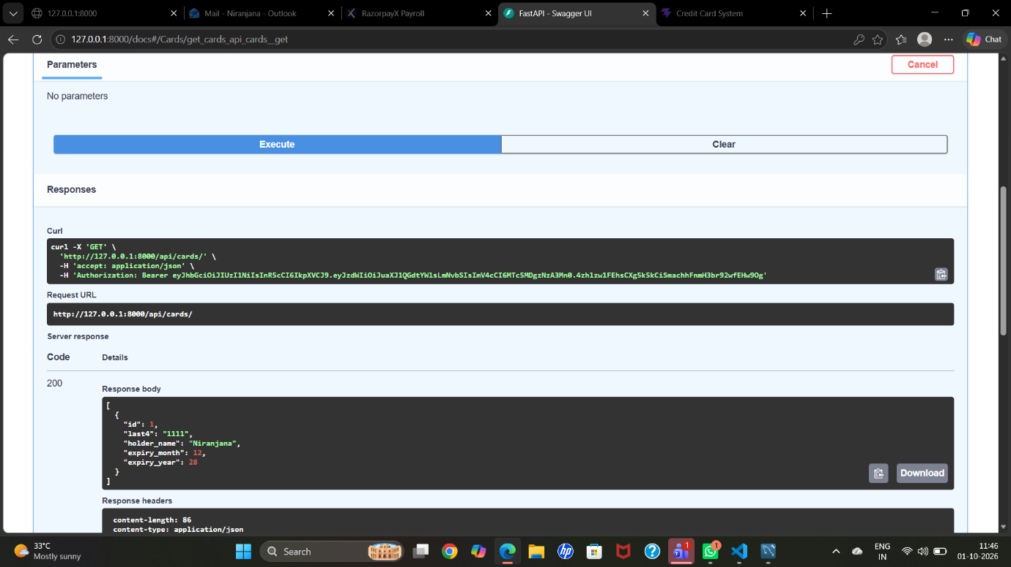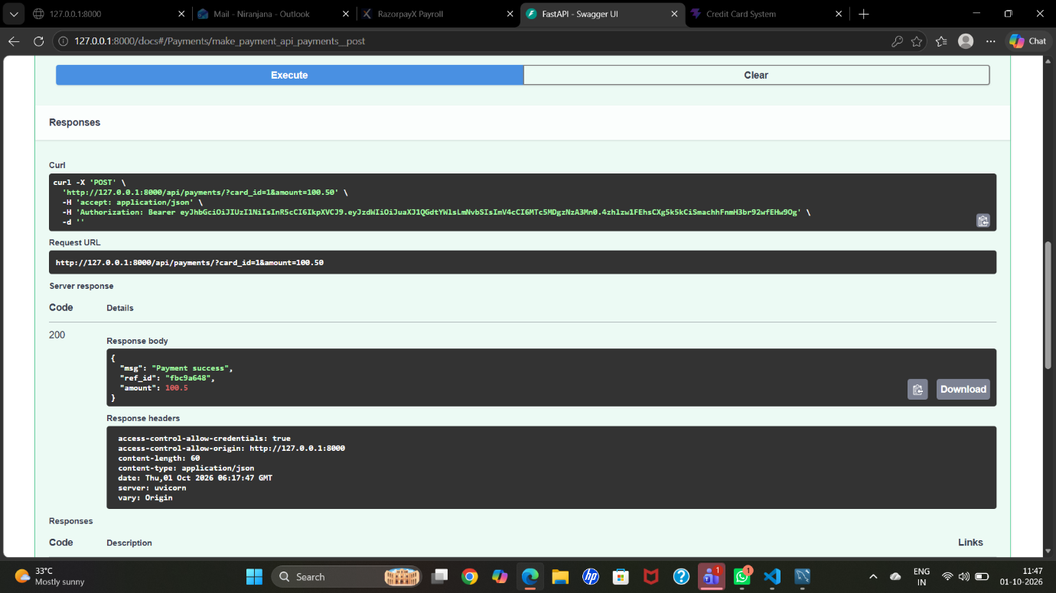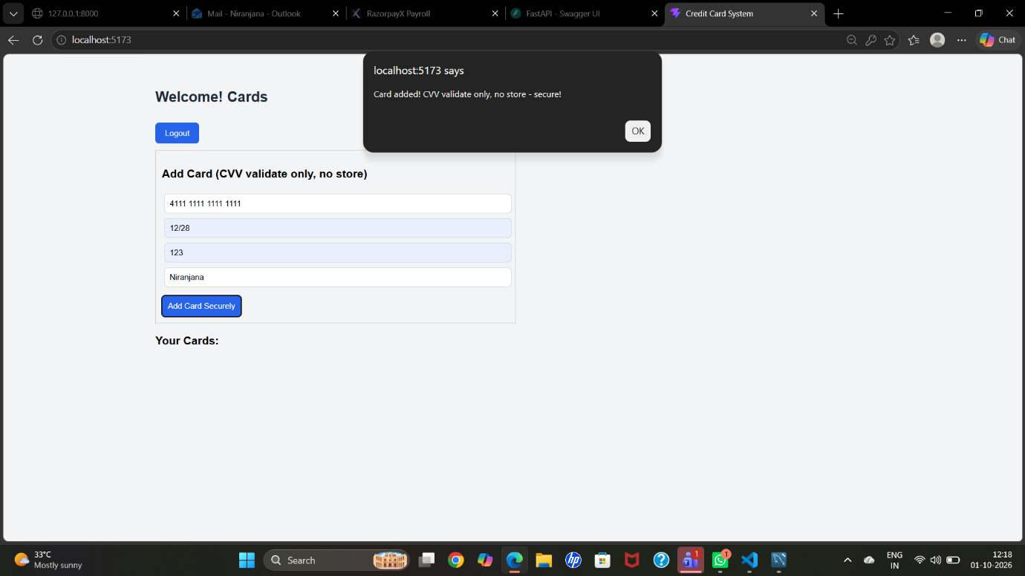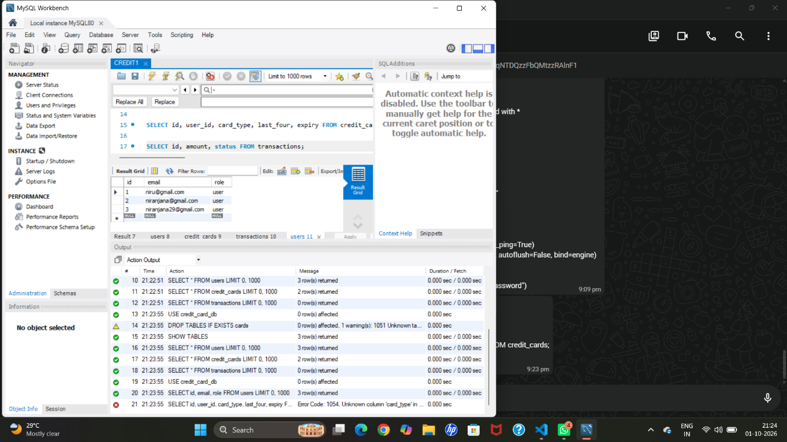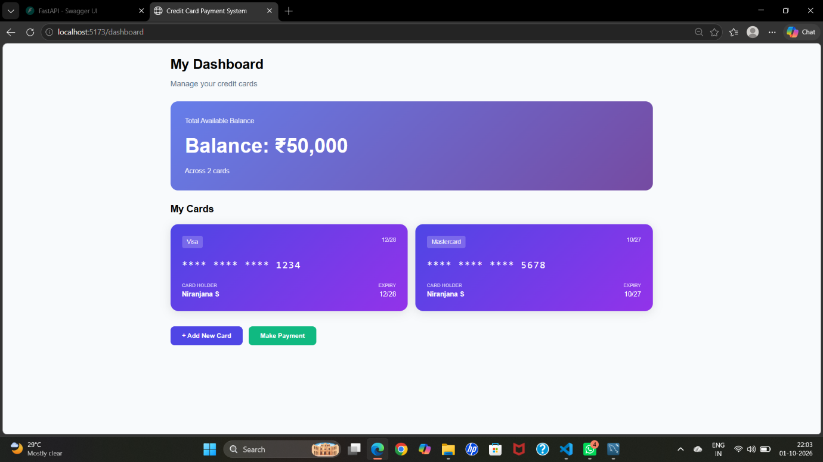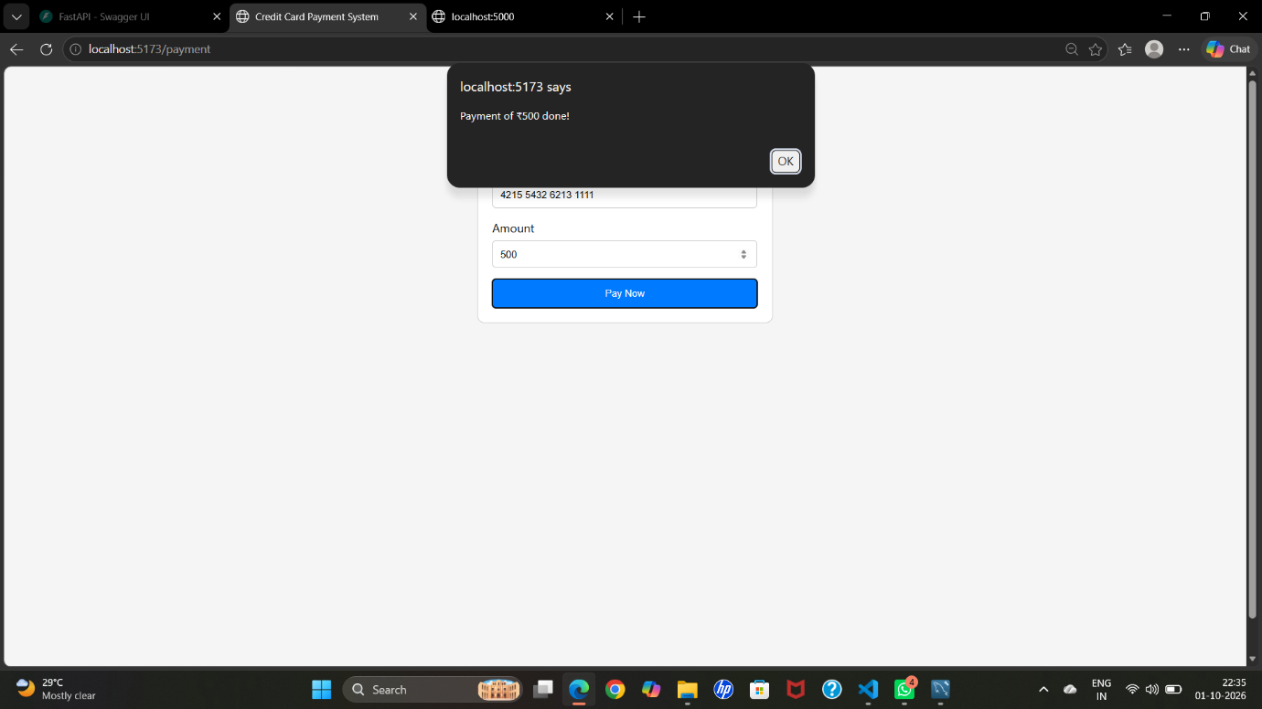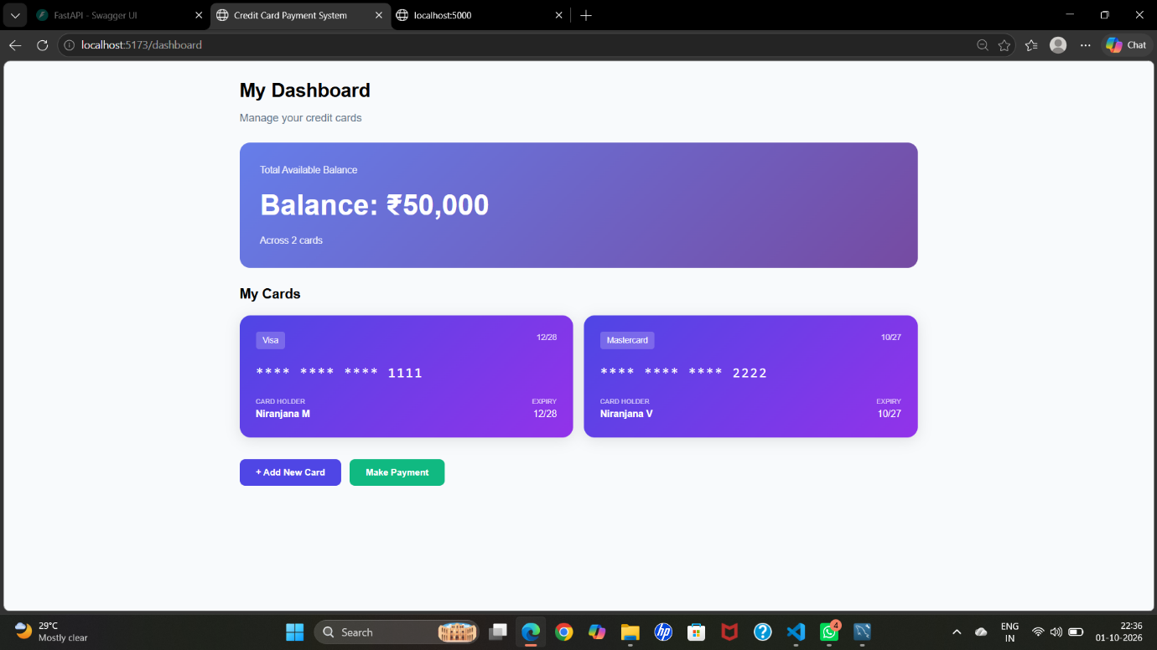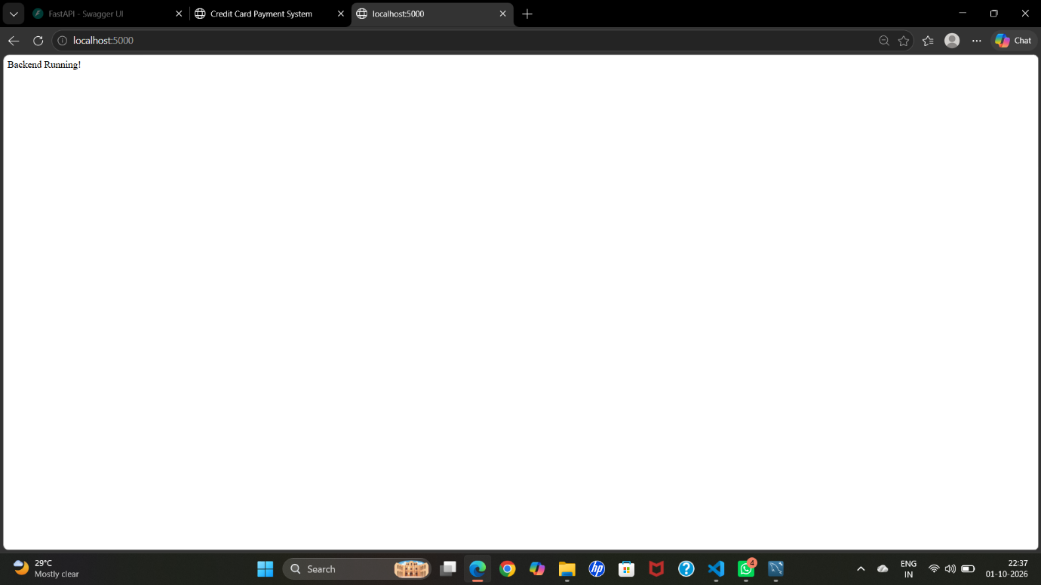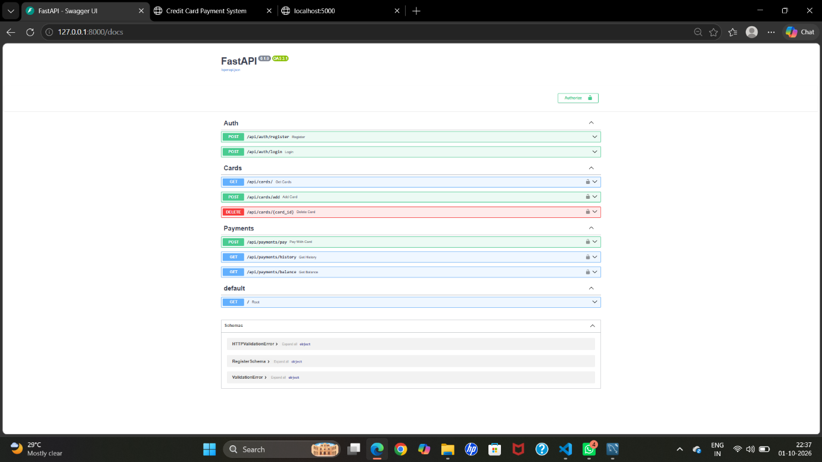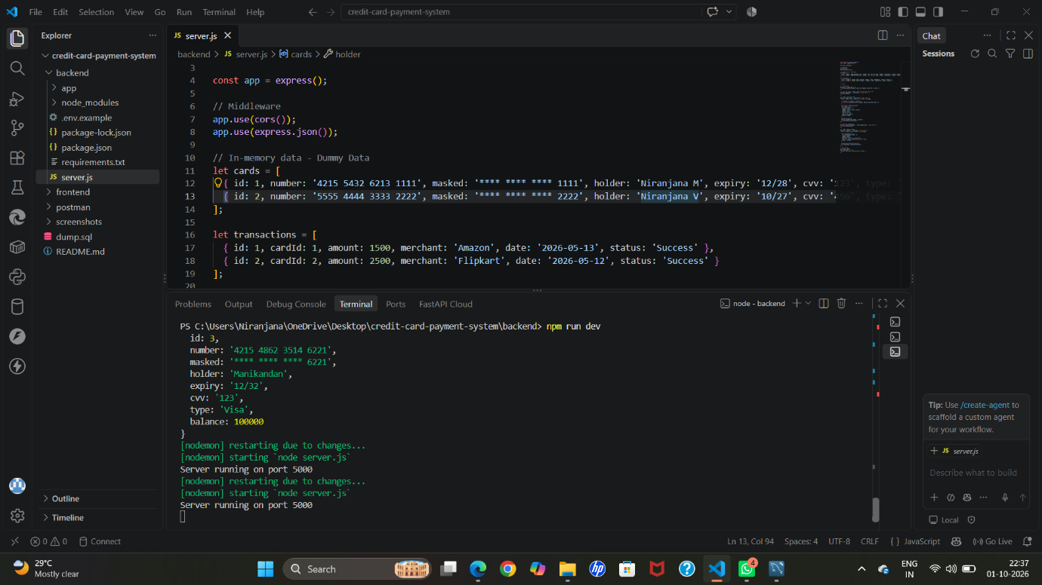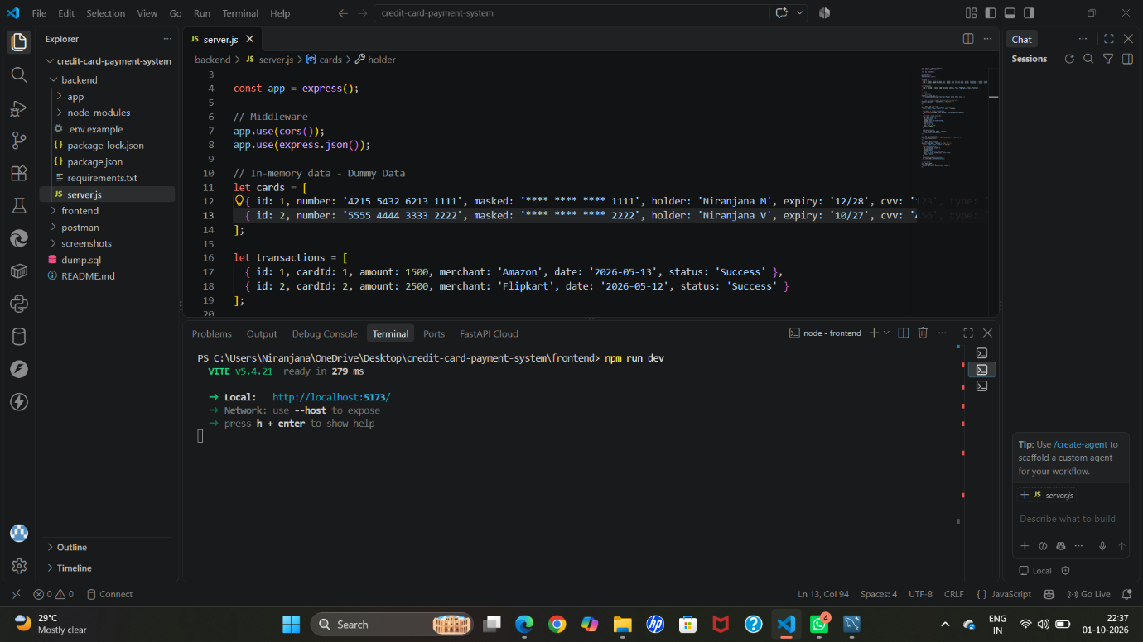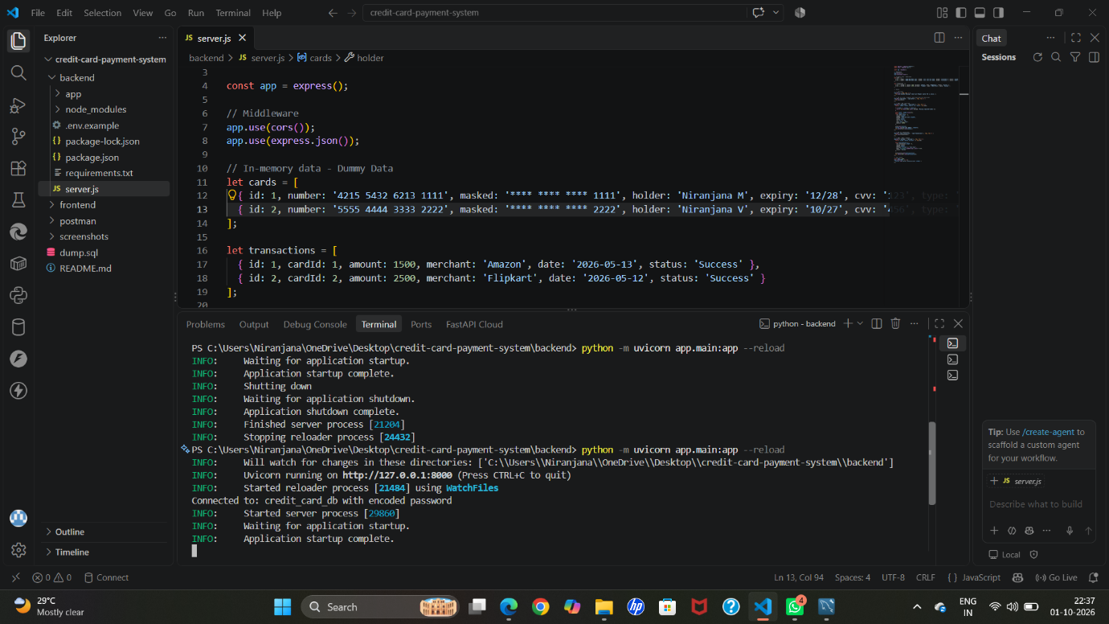

Conclusion :
The project successfully demonstrates the core principles of a modern fintech application. It is scalable, secure, and built using industry-standard practices. The decoupled architecture allows for easy integration of a real database and payment gateway in the future. This system can be extended to a full-fledged digital wallet.

